Session Title
Now What: Mastering/Managing Self and Time

Objectives
Chiefs will be able to:
1. Discuss the basic principles of time management
- Create an effective “To Do” List
- Better manage inboxs
- Understand the concept of the whole person doctor

Some basic principles about time management
- Time keeps on moving - we might stop, but time doesn’t
- Our perception of time causes problems – our culture has changed the perception of time
- Time is a good thing – when used correctly, the time that we have can be maximized

Mazzone’s basic time management rules
- First things First
  - Time Management is NOT about doing more stuff
  - Time Management IS about doing things that contribute to a meaningful life
- Efficiency – Doing a task in less time
  - General Tips to be efficiency
    - Stay in the moment – work when you work, don’t when you don’t
    - 52 on, 17 off – best research suggests to do a task for about 52 minutes and take about a 17 minute break
    - Touch each thing (e-mail, inbox item) once
    - Dictate everything
    - Participate in System improvements
  - What to do with an inbox object
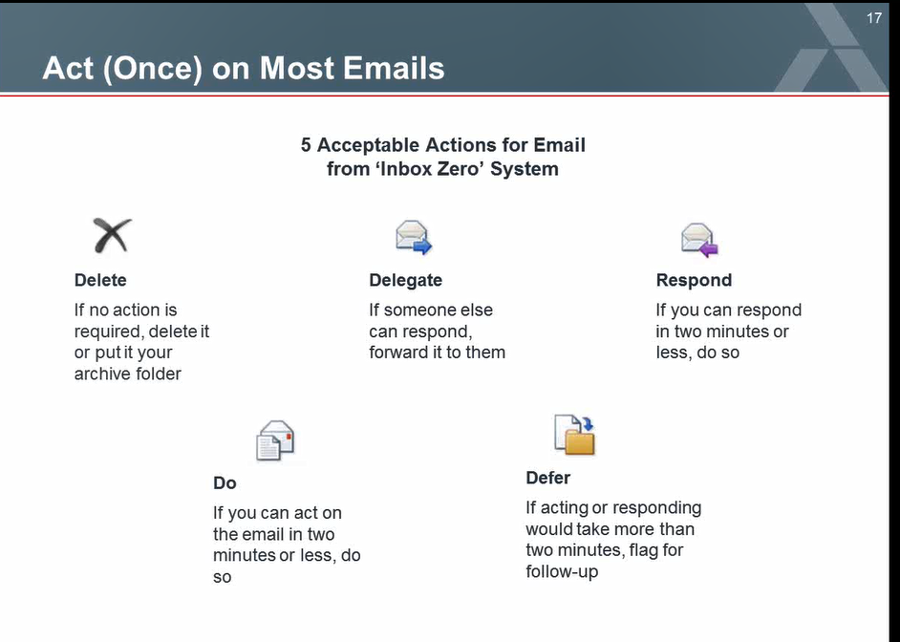

  - How to be an Inbox Ninja
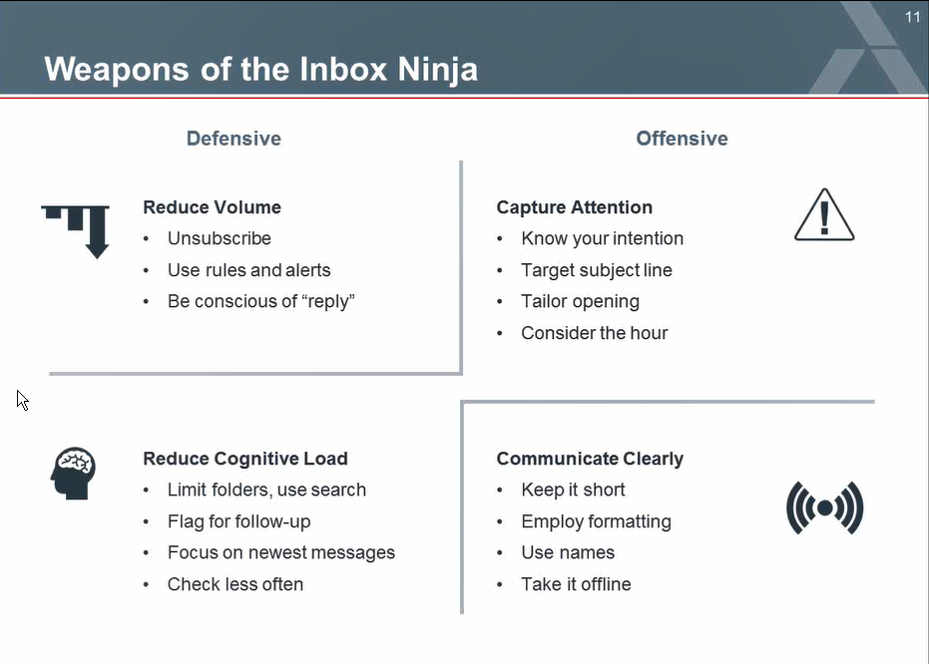

- Prioritization
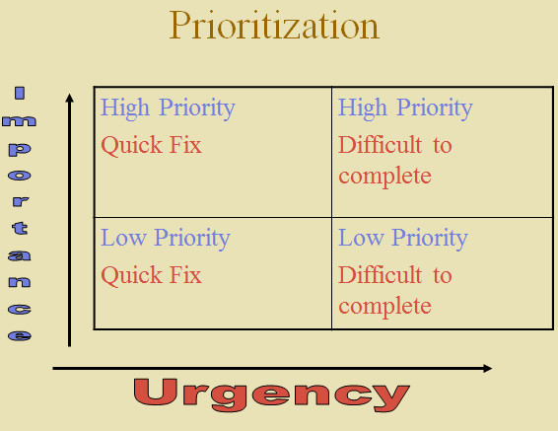

- Prioritize, prioritize, prioritize – just like the 1st 3 rules in real estate is location, location, location, the first job of time management is to decide what things need to have time spent on them. Urgency means how SOON does a task matter. Importance is how MUCH does a task matter. Significance is how LONG will the effects of a task last. Often we get caught up in the “tyranny of the now” (the little jobs that have to get done today) and never have time for the big jobs or the jobs we want to do. Then when these are due, we rush these as well, not giving them the time they deserve. By prioritizing we can avoid just doing the smaller less important things.

- Steps to take when choosing where to spend your time
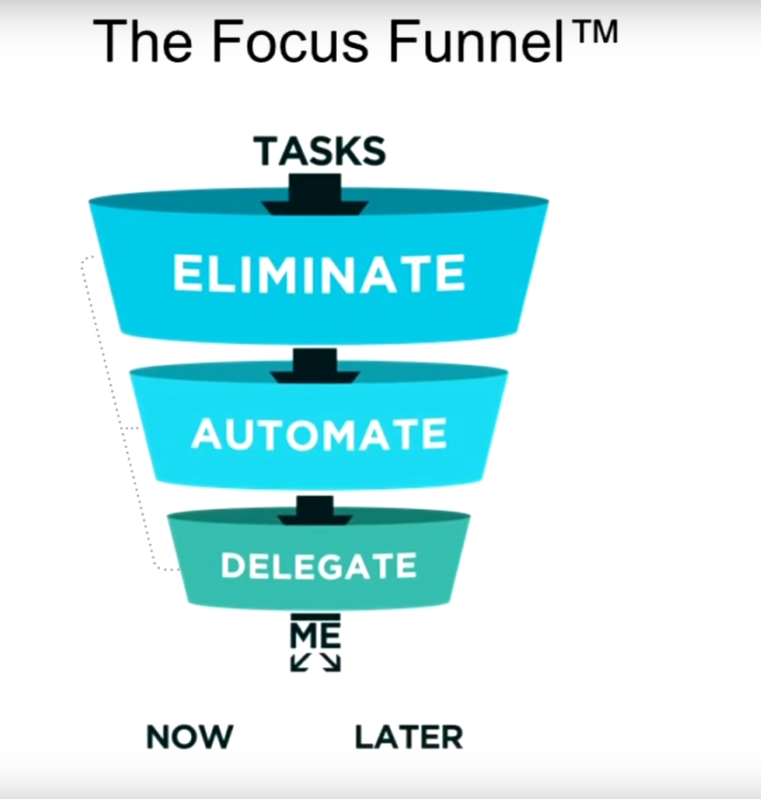

To do Lists

To do lists, if done properly can keep you on task and help you to manage your time. Always remember to manage the list and not have the list manage you. Some people find paper lists made daily including long and short term projects. Other people will update them weekly or as tasks arise. Some electronic tools (palm pilots, etc.) make organizing and tracking tasks more streamline. The important thing is to use a system that you will use. Every goal should include – what you want to achieve (the goal), the steps needed to achieve it (the tasks) and when you expect to accomplish it(the deadline).

Do’s
–Structure your to do list according to YOUR priorities as well as your organization’s
–Use religiously
–Look short term and long term
–List individual tasks to meet larger goals

DON’T
–Take longer on your list then you do on your “To Do’s”
–List what you have already done so you can check it off

Things to look for in To Do Apps

Synchronize multiple lists

Reorder tasks

Quick capture – voice activated/ fill in features

Group and ungroup

Make sub-tasks

Mark importance

Mark urgency

Available on multiple platforms

Alexa enabled

Advice to stay human

- Never be JUST a doctor – have hobbies or things you like to do outside medicine
- Never just work
- Spend time with family and friends
- Take frequent breaks
- Carve out a chunk of time each day--at least 15 minutes -- that is strictly your own.
- Create "snow days" once in a while
- Stop focusing on just the "big stuff"
- Make time for what it is you like to do
- Don't sacrifice vacations

References

Excellent Texts:
- The 7 Habits of Highly Effective People : Powerful Lessons in Personal Change
by Stephen R. Covey

- The Fifth Discipline : The Art and Practice of the Learning Organization
by Peter M. Senge
- The 10 Natural Laws of Successful Time and Life Management : Proven Strategies for Increased Productivity and Inner Peace
by Hyrum W. Smith

- How to Get Control of Your Time and Your Life
by Alan Lakein
- 101 Ways to Make Every Second Count : Time Management Tips and Techniques for More Success With Less Stress
by Robert W. Bly
- Fish! Tales
by Stephen C. Lundin

Web based:
Excellent time management tips: http://www.mindtools.com
On line time management course: http://www.interlearning.com/prodtimemgt.htm

To Do List Apps
- Habit RPG (www.Habitrpg.com ) – makes a game out of to do lists
- Any.do (www.any.do/anydo/ )
- Wunderlist (www.wunderlist.com )
– ToDoist (www.todoist.com )
- Microsoft To-do (https://todo.microsoft.com/en-us )
- Toodledo ( www.Toodledo.com )
- Remember the Milk - www.Rememberthemilk.com
- Evernote (www.evernote.com )
- Google Tasks (just google it ☺)

